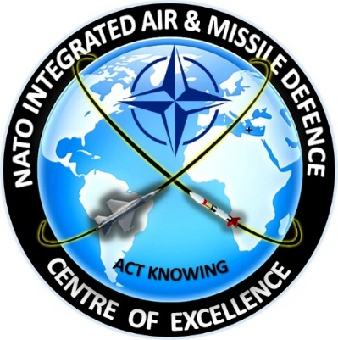

HELLENIC NATIONAL DEFENCE

GENERAL STAFF
STRATEGY AND POLICY BRANCH
TRANSFORMATION DIRECTORATE
TRANSFORMATION AND STRATEGIC ANALYSIS DEPARTMENT
IAMD COE

REGISTRATION FORM

NATO IAMD COE 1st Establishment Conference, Athens, 28th–31st Jan 2019

- PERSONAL INFORMATION (in CAPITAL LETTERS)
Surname*:
First Name*:
Title/Rank:
Gender (Male/Female):
Country*:
National Service*
(Army/Navy/Air Force):
Unit/Organization*:
Passport Number*:
Cell Phone*:
E-mail*:
Accommodation details (Hotel name)*
Additional Info **
*Mandatory field

** In case you bring a Laptop let us know the brand name and SN in order to get clearance.
- TRANSPORTATION DETAILS

 | Date | Time | Flight number | From | To | Transport from/to airport
Arrival |  |  |  |  |  | YES  NO
Departure |  |  |  |  |  | YES  NO

- ATTENDANCE TO SOCIAL EVENTS

EVENT
ICE BREAKER (28thJAN 2019) | YES | NO
VISIT TO ACROPOLIS MUSEUM 31stJAN 2019) | YES | NO

NOTE: Please submit your registration form by e-mail to NATO IAMD COE Est. Team:
LTC (ARTY) PanagiotisPAPPASp.pappas@hndgs.mil.gr
MAJ (ARTY) Manos KIOUTSOUKALISm.kioutsoukalis@hndgs.mil.gr

Answers from participants should be received not later than 7 Jan 2019.

